di What were the a nswers??

Section A

a. [(1,1,-2)T]

Basis of intersection:T

$$U1 ∩{} U2 = span \{\left[-1, -1, 2 \right]T\}$$

b.

i.

Eigen values = 1, 2

ii.

Not diagonalisable

C.

I. No, Ψ(0) = (-2,0,0), so the mapping is not linear.

ii.

iii.

Not a subspace

Section B

1. Proof of convergence:

-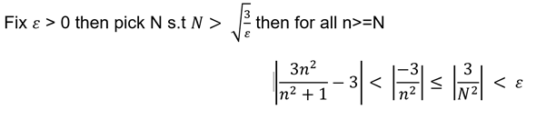

Lots of proofs of convergence / divergence.

b.

-x - (x^2)/2 + (x^3)/6

c.

i) Disclaimer: I did not have time to write that down in the actual exam, and I am sure there is a better method to do it since my method needs to use Bernoulli’s inequality which we haven’t learnt yet during lectures...

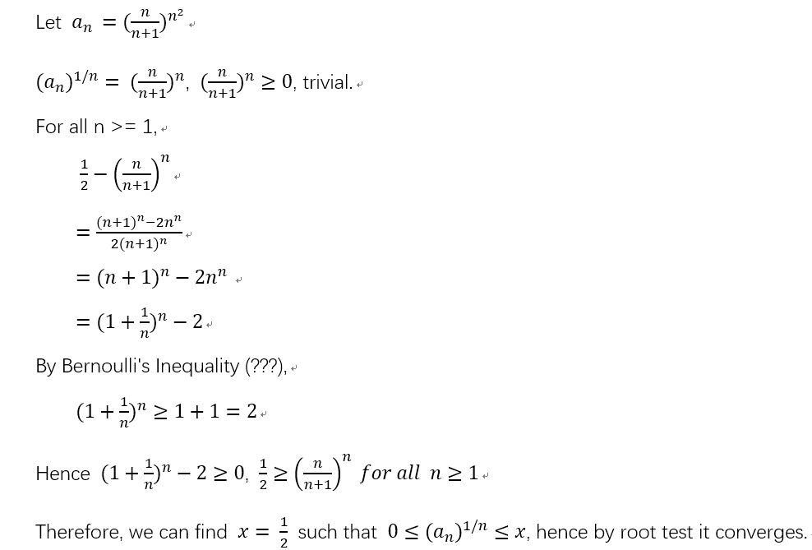

Alternative

$$a_{n} = (\frac{n}{n+1})^{n^{2}}$$

$${(a}_{n})^{1/n} = (\frac{n}{n+1})^{n} ≥0$$

$${(a}_{n})^{1/n} = (\frac{1}{(n+1)/n})^{n}$$

$${(a}_{n})^{1/n} = (\frac{1}{1 + 1/n})^{n}$$

${\lim_{n→∞} (1+\frac{1}{n})^{n}}_{} = e$ definition of e

${\lim_{n→∞} (\frac{1}{1 + 1/n})^{n}}_{} =\frac{1}{e}$ $We can find x = 1/e such that 0 ≤ (a_{n})^{1/n}≤x therefore by root test it converges$

ii) let a{n} = 1/n

Consider $\ln\left(\lim_{n→∞}{{\left(\frac{1}{n}\right)}^{\frac{1}{n}}}\right) = \ln\left(\lim_{n→∞}{\frac{1}{{\frac{1}{n}}^{\frac{1}{n}}}}\right) = -\lim_{n→∞}\left(\ln\left(n^{\frac{1}{n}}\right)\right)$ use L’Hopital to get = 0

Thus if ln(_) = 0, _ = 1 so lim of a{n} = 1

Repeat for when a{n} = 1/n^2

We know that the infinite sum of 1/n diverges (from lecture notes)

But infinite sum of 1/n^2 converges (from lecture notes)

Since they both give 1 in the root test, the root test doesn’t tell us anything about convergence/divergence when L = 1.